**DIGITAL MARKETING CAMPAIGN FOR CADBURY**

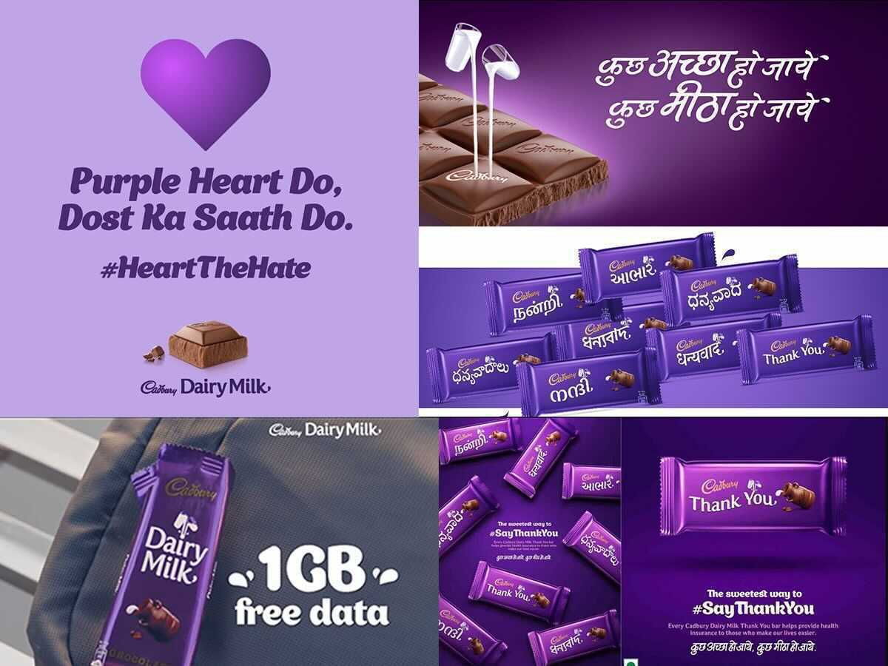

**CAMPAIGN NAME :- "Sweet Moments with Cadbury"**

[](https://www.youtube.com/embed/asUQ-9oMynQ?feature=oembed)

**“KUCH MEETHA HO JAYE”**

**OBJECTIVES OF THE CAMPAIGN**

1. **Emotional Connection:**
   * The campaign successfully taps into the emotional aspect of sharing sweetness with loved ones, reinforcing Cadbury's position as a brand that enhances moments of joy and celebration.
2. **Cultural Significance:**
   * It aligns well with Indian culture, where sweets play a vital role in festivities and social gatherings. This localization strengthens the brand's relevance in the Indian market.
3. **Variety of Offerings:**
   * Cadbury’s diverse product range appeals to various consumer preferences, from chocolate bars to special gift packs, ensuring that there’s something for every occasion.
4. **Effective Marketing:**
   * The campaign employs a mix of traditional and digital marketing strategies, engaging consumers across platforms and maximizing reach. Touching advertisements and creative storytelling have made it memorable.
5. **Brand Loyalty:**
   * By associating itself with joyful moments, Cadbury fosters a sense of loyalty among consumers who associate the brand with happiness and togetherness.

**Key message of the campaign:-**

1. Share the Joy" - Highlights the emotional connection of sharing Cadbury chocolates with loved ones.
2. "Indulge in Sweetness" - Focus on the rich, creamy taste and quality of Cadbury chocolates.

**HERE ARE SOME MORE DIGITAL CAMPAINS BY CADBURY:**

1. **Pappu Pass Ho Gaya (2006):**

**The ad showed a boy named Pappu excitedly informing his father about his success in passing his exams, and [](https://www.youtube.com/embed/DK3FCkf8xZA?feature=oembed)the father responds by sharing a Cadbury Dairy Milk with everyone around him. The campaign resonated with Indian parents and students, highlighting the joy of academic success.**

1. **BADHTI DOSTI KE NAAM, KUCH MEETHA HO JAE (2013):**

**This campaign focused on strengthening friendships and sharing sweet moments with friends. The ads depicted different scenarios where friends came together to share a Cadbury Dairy Milk, reinforcing the chocolate’s role in building connections and celebrating friendships.   
[](https://www.youtube.com/embed/yICX_ZQ86Mw?feature=oembed)**

1. **CADBURY CELEBRATIONS-RAKSHA BANDHAN(2018):**

#### **The Cadbury Celebrations Raksha Bandhan campaign beautifully captured the bond between siblings in India. Raksha Bandhan is a festival that celebrates the love and protection between brothers and sisters, and the ads showcased heartwarming moments of sibling love, with Cadbury Celebrations as the ideal gift for the occasion. The campaign resonated with Indian families, further establishing Cadbury Celebrations as the go-to choice for festive gifting. Cadbury’s ability to resonate with its audience’s cultural and emotional sentiments has made these campaigns successful and memorable.**

[](https://www.youtube.com/embed/oapzWU3ttqg?feature=oembed)

**BUYER’S PERSONA**

A buyer's persona is a semi-fictional representation of your ideal customer based on market research and real data about your existing customers.

**Buyer Persona: Ashu the cadbury Shopper**

**Name:** Ashu

**Demographics:**

•**Age**: 17

•**Gender**: Female

•**Marital Status**: unmarried

•**Children**: 0

•**Education:** 11th

•**Household Income**: 9,00,000 per year

•**Location:** Thane Mumbai

**Personal Background:**

•**Hobbies**: Enjoys singing, dancing, travelling .

•**Values**: face clean, health, and family.

•**Personality**: Analytical, organized.

**Goals:**

**•Primary Goal**: To find high-quality, eco-friendly products for her health & family that offer good value for money.

•**Secondary Goal:** To stay informed about the latest trends in marketing and consumer behavior.

**Behavioral Traits:**

•S**hopping Preferences:** Prefers offline shopping due to in store discount aand variety of product .

• **Technology Usage:** Active on social media (especially Instagram and Pinterest), uses a smartphone for most of her online activities, and relies on product reviews and recommendations.

**•Buying Decision Influences**: Heavily influenced by online reviews, word-of-mouth recommendations, and social media endorsements from influencers she trusts.

**Brands and Influences:**

• **Favorite Brands**: Cadbury , Apple , Nike

• **Influencers**: Follows lifestyle bloggers, eco-friendly product reviewers, and parenting influencers on social media.

**Marketing Message:**

•**Core Message**: "buy the good quality of product which is not harmful for your health”

**Channels and Content:**

• **Preferred Channels:** Social media Instagram and snapchat

•**Content Types:** Informative articles, product reviews, how-to guides, and inspirational lifestyle content.

This persona helps to understand the needs, preferences, and challenges of a segment of your target audience, allowing you to tailor your marketing strategies effectively.

**CONTENT**

**Campaign: -** The **'Kuch Meetha Ho Jaye'** campaign featured a wide range of advertisements, each focusing on different aspects of life's sweetness

**Campaign Duration:**

1 month (e.g., during the festive season or leading up to Valentine’s Day)

**Campaign Components:**

**1. S**ocial Media Activation

2.Create a unique hashtag: **#KuchMeeethaHoJaye**

1. Influencer collaboration
2. Special promotions

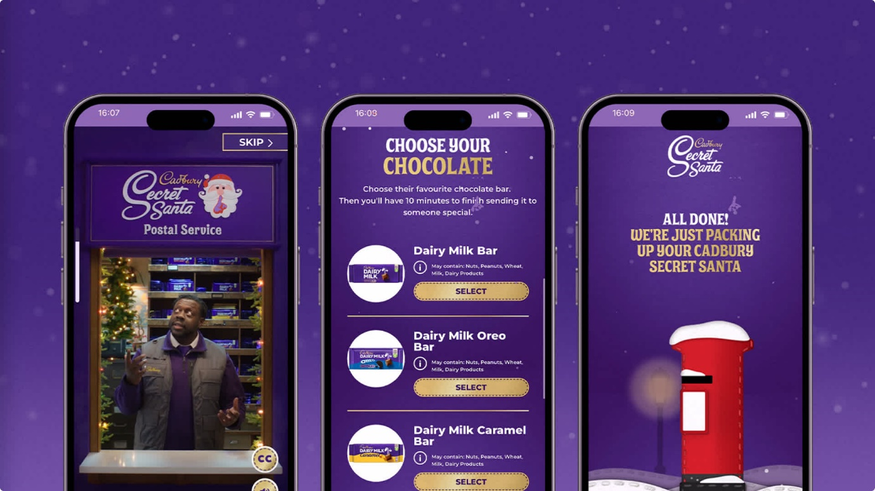

**Channels of marketing**

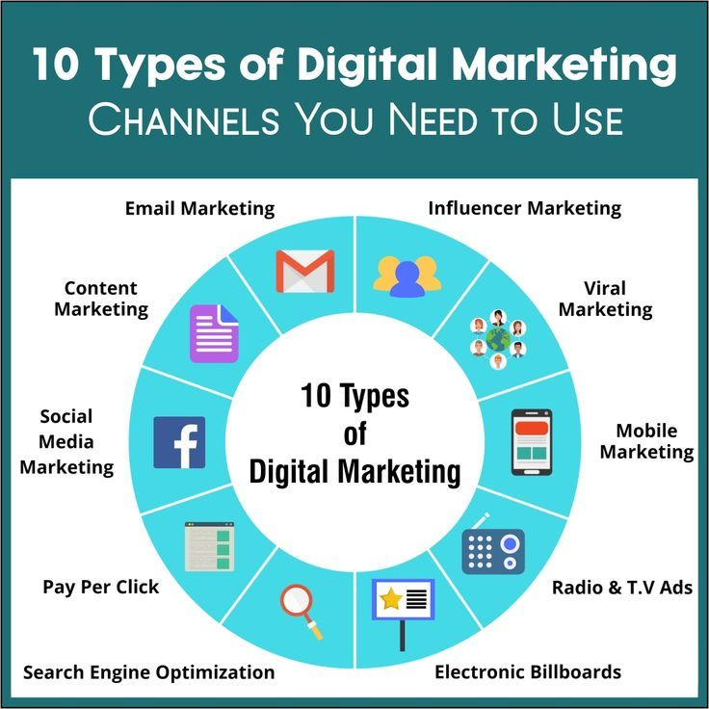

1. **Social Media**:
   * **Instagram & Facebook**: Post engaging visuals of Cadbury products, user-generated content, and behind-the-scenes videos. Use stories and reels to showcase recipes and creative ways to use Cadbury chocolates.
   * **Twitter**: Engage in real-time conversations and use trending hashtags. Conduct polls about favorite Cadbury products.
2. **Email Marketing**:
   * Send out newsletters featuring recipes, special promotions, and user testimonials about sweet moments with Cadbury.
   * Personalize emails based on past purchase behaviour to recommend specific products.
3. **Website & E-commerce**:
   * Revamp the Cadbury website with interactive features like a "Chocolate Finder" quiz that recommends products based on user preferences.
   * Collaborate with e-commerce platforms for exclusive online offers.
4. **Content Marketing**:
   * Create blog posts and videos about the history of chocolate, Cadbury’s sustainability efforts, and recipes that include Cadbury products.
   * Launch a "Sweet Moments" blog series where customers share their experiences and stories involving Cadbury.
5. **Influencer Partnerships**:
   * Partner with food bloggers and lifestyle influencers to create authentic content featuring Cadbury products.
   * Host Instagram takeovers where influencers share their favourite ways to enjoy Cadbury.
6. **Interactive Campaign**:
   * Launch an interactive online contest or challenge (e.g., #CadburyMoments) where participants share their sweetest moments with Cadbury, offering a chance to win Cadbury gift hampers.
7. **Paid Advertising**:
   * Utilize Google Ads for targeted keywords related to chocolate and gifting.
   * Invest in social media ads showcasing new or seasonal products to generate interest and traffic.

**TIMELINE**

|  |  |  |  |  |
| --- | --- | --- | --- | --- |
| DAY | DATE | ACTIVITY | DETAILS | RESPONSIBLE TEAM |
| MONDAY | **SEP 19,2024** | **Campaign kick-off** | **Announcement: Launch campaign hashtag(#JOYOFDIARYMILK) across all channels. Countdown posts- create Instagram stories and Facebook countdowns.** | **MARKETING MANAGER, SOCIAL MEDIA TEAM** |
| TUESDAY | **SEP 20,2024** | **Social media engagement** | **Interactive polls- conduct polls on Instagram stories and twitter. Quizzes- post fun quizzes on Facebook and Instagram.** | **SOCIAL MEDIA COORDINATOR** |
| WEDNESDAY | **SEP 21,2024** | **Video content launch** | **Promotional video- release a video that highlights DIARY MILK. Influencer posts- coordinate with influencers for content sharing.** | **CONTENT MARKETING TEAM, INFLUENCER RELATIONS** |
| THRUSDAY | **SEP 22,2024** | **Influencer collaboration** | **Content Sharing- post content from influencers.** | **INFLUENCER RELATIONS, SOCIAL MEDIA TEAM** |
| FRIDAY | **SEP 23,2024** | **User generated content push** | **Community Challenge- launch a challenge for followers to share recipes/moments. Feature posts- highlight user generated content on social media.** | **SOCIAL MEDIA COORDINATOR, COMMUNITY MANAGER** |
| SATURDAY | **SEP 24,2024** | **Contest announcement** | **Launch Contest- announce the best recipe contest with promotional ads. Contest Details- communicate participation guidelines and prizes.** | **MARKETING TEAM, GRAPHICS DESIGNER** |
| SUNDAY | **SEP 25,2024** | **Performance check & response** | **Metrics Review- analyse engagement and sales data from the week. Community engagement- respond to comments/messages, share the insights.** | **ANALYTICS TEAM, SOCIAL MEDIA COORDINATOR** |

**BUDGET**



1. **Marketing & Advertising (30-40%)**
   * Traditional Media (TV, print)
   * Digital Advertising (social media, online video, PPC)
   * Sponsorships and Promotions
   * Brand Partnerships
   * Market Research and Consumer Insights
2. **Operations (20-25%)**
   * Manufacturing and Production Costs
   * Supply Chain Management
   * Quality Control and Compliance
   * Distribution and Logistics
3. **Technology and E-commerce (15-20%)**
   * Website and Mobile App Development
   * E-commerce Platform Enhancements
   * Data Analytics and CRM Systems
   * Cybersecurity Measures
   * Technology Upgrades for Production Efficiency
4. **Sustainability (5-10%)**
   * Sustainable Sourcing of Ingredients (e.g., cocoa)
   * Environmental Initiatives (water conservation, energy efficiency)
   * Packaging Innovations for Sustainability
   * Community Engagement and Social Responsibility Programs
5. **Product Development (10-15%)**
   * R&D for New Flavor Profiles and Products
   * Market Testing and Consumer Feedback
   * Packaging Development
   * Healthier Product Alternatives (e.g., reduced sugar)
6. **Expansion & Real Estate (5-10%)**
   * New Manufacturing Facilities
   * Retail Space Expansion
   * Warehousing and Logistics Infrastructure
   * Entry into New Markets (regional or international)

**MEASUREMENT**

1. **Product Offering**

Cadbury, a brand owned by Mondelēz International, is well-known for its wide range of confectionery products, particularly chocolate. Its product offerings include:

* **Chocolate Bars**: Cadbury Dairy Milk, Crunchie, Wispa, Twirl, and others.
* **Chocolate Gifting**: Boxes of chocolates like Cadbury Roses and Celebrations.
* **Seasonal Products**: Special editions during holidays like Easter (e.g., Cadbury Creme Eggs).
* **Beverages**: Cadbury Hot Chocolate.
* **Snacking**: Products like Cadbury Buttons, and various chocolate-covered snacks.

1. **Market Reach**

Cadbury has a significant global presence, with its products sold in numerous countries around the world. Key aspects include:

* **Geographical Scope**: Strong presence in the UK, India, Australia, and many other markets.
* **Consumer Base**: Appeals to a wide demographic, from children to adults, with a variety of products catering to different tastes and preferences.
* **Retail Channels**: Products are available in supermarkets, convenience stores, online platforms, and specialty stores.

1. **Sustainability**

Cadbury has committed to sustainability through various initiatives:

* **Cocoa Sourcing**: The Cocoa Life program aims to source sustainable cocoa, focusing on improving the livelihoods of cocoa farmers and preserving the environment.
* **Packaging**: Cadbury is working towards using 100% recyclable packaging by 2025.
* **Carbon Neutrality**: The company is taking steps to reduce its carbon footprint, with efforts targeting energy use in production and logistics.
* **Community Engagement**: Investments in local communities, education, and sustainable farming practices.

1. **Employee Base**

As a major global brand, Cadbury employs a substantial workforce:

* **Diversity and Inclusion**: Efforts to create a diverse and inclusive workplace across various regions.
* **Employee Programs**: Investments in training and development, with a focus on employee well-being and career growth.
* **Job Opportunities**: Positions ranging from manufacturing and supply chain to marketing and sales.

1. **Technology & Innovation**

Cadbury leverages technology and innovation in various ways:

* **Product Development**: Continuous innovation in flavors, formats, and health-conscious options (e.g., lower sugar products).
* **Manufacturing**: Adoption of advanced manufacturing technologies to improve efficiency and product quality.
* **Digital Transformation**: Enhanced online presence and e-commerce strategies to reach consumers directly.
* **Supply Chain Management**: Use of technology for better logistics and inventory management.

**CONCLUSION**

The "Kuch Meetha Ho Jaye" digital campaign has successfully strengthened Cadbury's connection with its audience in the digital sphere while reinforcing the brand's essence. The campaign not only drove sales but also fostered a community of brand advocates who see Cadbury as an integral part of their celebrations and everyday moments.

**Final Thoughts**

In conclusion, the campaign has been a testament to how digital marketing strategies can effectively engage and resonate with consumers. By combining emotional storytelling with innovative interaction, Cadbury has effectively positioned itself as a go-to brand for sweetness in both big milestones and everyday life, ensuring that the spirit of "Kuch Meetha Ho Jaye" continues to thrive in consumers' hearts and minds.